Part A 1
Part B 1
Part C 1
Part D - Compressor 3
Part E Limiter 7
Part F Expander 12
Part G Noise Gate: f1 & f3 17
Part G Noise Gate: f3 22
Part H 27
% Kevin Quizhpi
% DSP Design
% Project 2
% 9/26/17

Part A
% Establishing anonymous funtion for input x(t)
X = @(t,A,f) A*cos(2*pi*f*t);
MeanSqAvg = @(A) A^2 /2;
AbsAvg = @(A) 2*A /pi;

Part B
% Constants used for parts c-g
fs = 8000;
Ts = 1/fs;
ep = 0.1;
LbAtck = ep ^ (Ts/(2/1000));
LbRels = ep ^ (Ts/(1/100));

Part C
% We create the signal x(t) that is made up of a concatenation of three
% signals each of 25ms length each.
fo = [0.3 0.6 1]*1000;
Ao = [2 4 0.5];
to = [0 25 50]/1000;
Smp = 0.025*fs; % number of samples per 25ms section
% Function used to extract real world time from the current sample
time = @(n,t0) n/(Smp-1) *0.025 + t0;
x = zeros(1,Smp*3);
for i =1:3
for n = 1:Smp
t = time(n-1,to(i));
x(n + 200*(i-1)) = X(t,Ao(i),fo(i));
end
end
% Mean absolute values
x1MA = AbsAvg(Ao(1)); % 1.2732
x2MA = AbsAvg(Ao(2)); % 2.5465
x3MA = AbsAvg(Ao(3)); % 0.3183
n = 1:length(x);
% Plot of created input signal
figure;
plot(n/8,x(n));
title('input signal, x(t)');
xlabel('t (msec)');
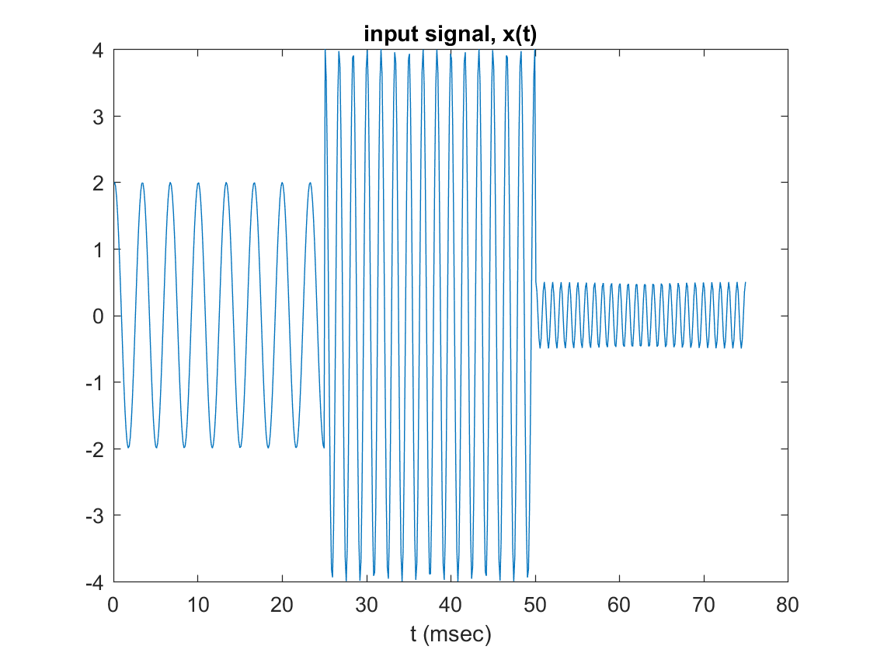

Part D - Compressor
% For the compressor p should have a value between 1/4 & 1/2
p = 1/3;
c0 = 1;
D = 0;
% I've chosen to use the FIR smoothing filter and it requires the use of a
% circular buffer of length L
L = ceil((1+LbAtck)/(1-LbAtck));
MvAvgBuf = zeros(1,L);
% Function used to obtain the index of circular buffer
pt = @(i) mod(i,L-1) + 1;
MvAvgSum = 0;
MvAvgOld = 0;
cPrev = 0;
% Initializing arrays of output signals
c = zeros(1,length(x));
g = zeros(1,length(x));
G = zeros(1,length(x));
y = zeros(1,length(x));
% Level detector
cN = @(xn,cPrev) (LbAtck* cPrev + (1-LbAtck)*abs(xn)).*(abs(xn) >= cPrev) ...
+ (LbRels*cPrev + (1 - LbRels).*abs(xn)).*(abs(xn) < cPrev);
% Gain Processor functions both Compressor and Expander
gCom = @(c) (c/c0)^(p-1)*(c>= c0) + 1*(c <=c0);
gExp = @(c) (c/c0)^(p-1)*(c <=c0) + 1*(c>= c0);
% Since we are compressing the signal I will use gCom
for i = 1:length(x)
xn = x(i);
c(i) = cN(xn,cPrev);
cPrev = c(i);
g(i) = gCom(c(i));
MvAvgOld = MvAvgBuf(pt(i-1));
MvAvgBuf(pt(i-1)) = g(i);
MvAvgSum = MvAvgSum + g(i) - MvAvgOld;
G(i) = MvAvgSum/L;
y(i) = G(i)*xn;
end
figure;
plot(n*3/25,y, n*3/25, ones(1,length(n))*c0,'--')
title('compressor, y(t) = G(t)x(t)');
xlabel('t (msec)');
figure;
plot(n*3/25,c, n*3/25, ones(1,length(n))*c0,'--')
title('control signal, c(t)');
xlabel('t (msec)');
figure;
plot(n*3/25,g)
title('gain, g(t) = F(c(t))');
xlabel('t (msec)');
grid on;
figure;
plot(n*3/25,G)
title('smooth gain, G(t)');
xlabel('t (msec)');
grid on;
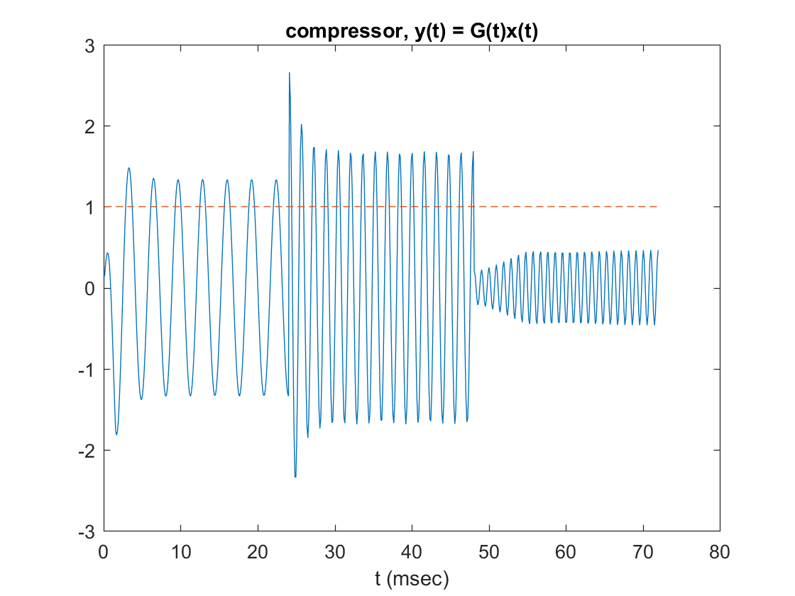
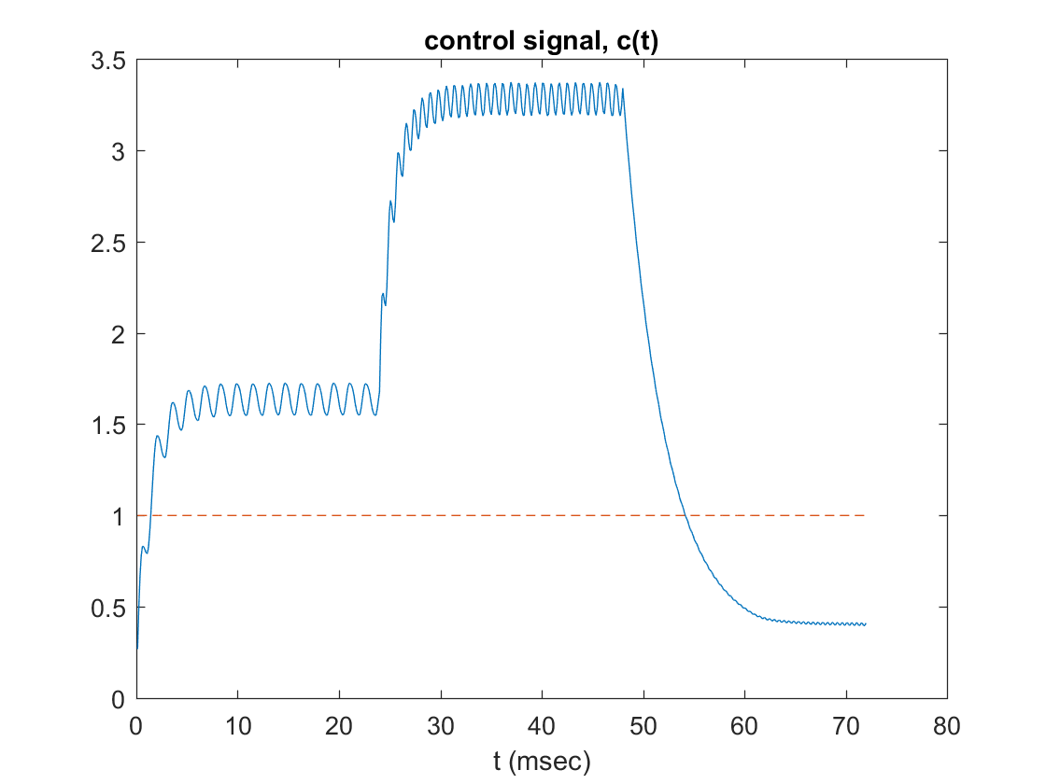
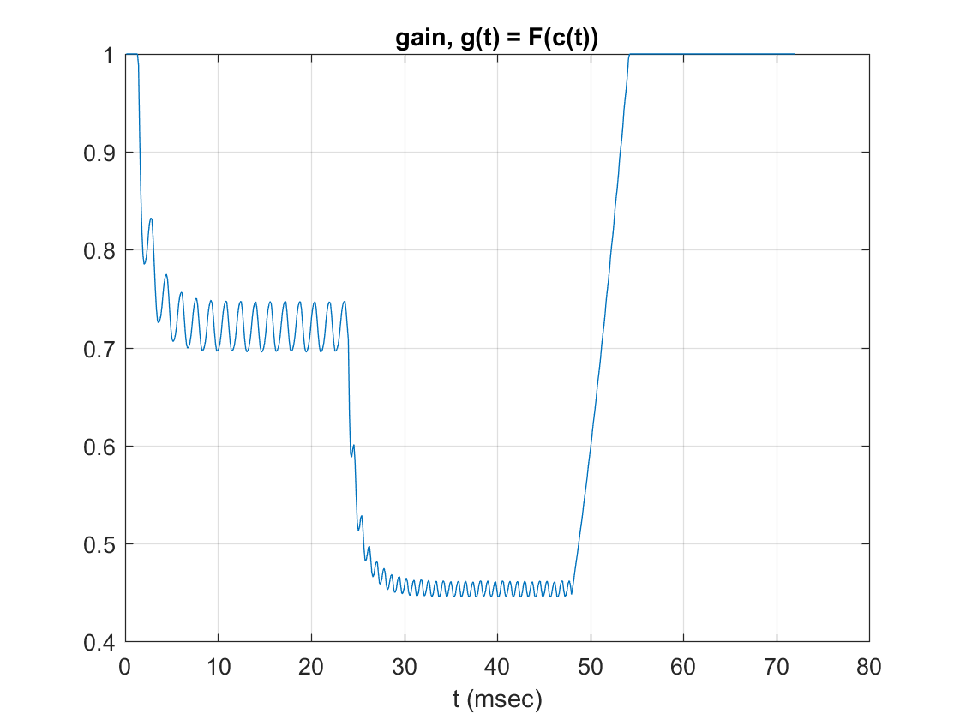
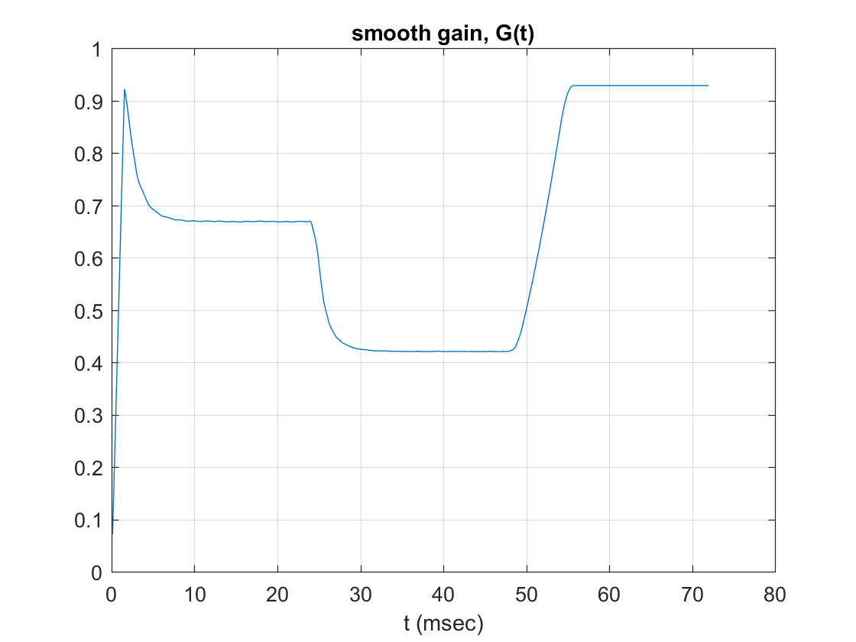

Part E Limiter
% For a limiter p should be much less than 1 arond the area of 1/10
p = 1/15;
c0 = 2;
MvAvgBuf = zeros(1,L);
pt = @(i) mod(i,L-1) + 1;
MvAvgSum = 0;
MvAvgOld = 0;
cPrev = 0;
c = zeros(1,length(x));
g = zeros(1,length(x));
% Level detector
cN = @(xn,cPrev) (LbAtck* cPrev + (1-LbAtck)*abs(xn)).*(abs(xn) >= cPrev) ...
+ (LbRels*cPrev + (1 - LbRels).*abs(xn)).*(abs(xn) < cPrev);
% Gain Processor functions both Compressor and Expander
gCom = @(c) (c/c0)^(p-1)*(c>= c0) + 1*(c <=c0);
gExp = @(c) (c/c0)^(p-1)*(c <=c0) + 1*(c>= c0);
% Since we are compressing the signal I will use gCom
for i = 1:length(x)
xn = x(i);
c(i) = cN(xn,cPrev);
cPrev = c(i);
g(i) = gCom(c(i));
MvAvgOld = MvAvgBuf(pt(i-1));
MvAvgBuf(pt(i-1)) = g(i);
MvAvgSum = MvAvgSum + g(i) - MvAvgOld;
G(i) = MvAvgSum/L;
y(i) = G(i)*xn;
end
figure;
plot(n*3/25,y, n*3/25, ones(1,length(n))*c0,'--')
title('compressor, y(t) = G(t)x(t)');
xlabel('t (msec)');
figure;
plot(n*3/25,c, n*3/25, ones(1,length(n))*c0,'--')
title('control signal, c(t)');
xlabel('t (msec)');
figure;
plot(n*3/25,g)
title('gain, g(t) = F(c(t))');
xlabel('t (msec)');
grid on;
figure;
plot(n*3/25,G)
title('smooth gain, G(t)');
xlabel('t (msec)');
grid on;
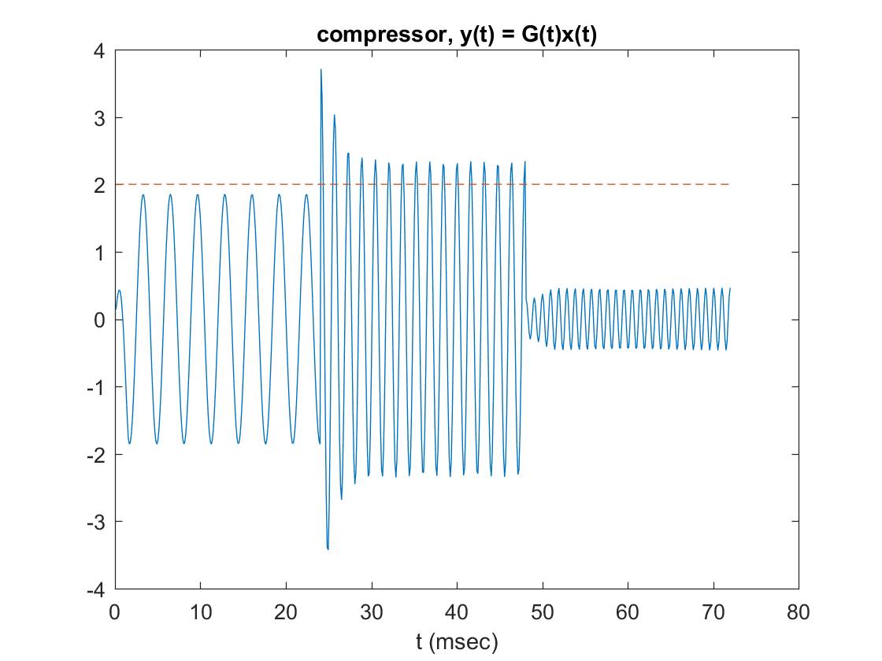
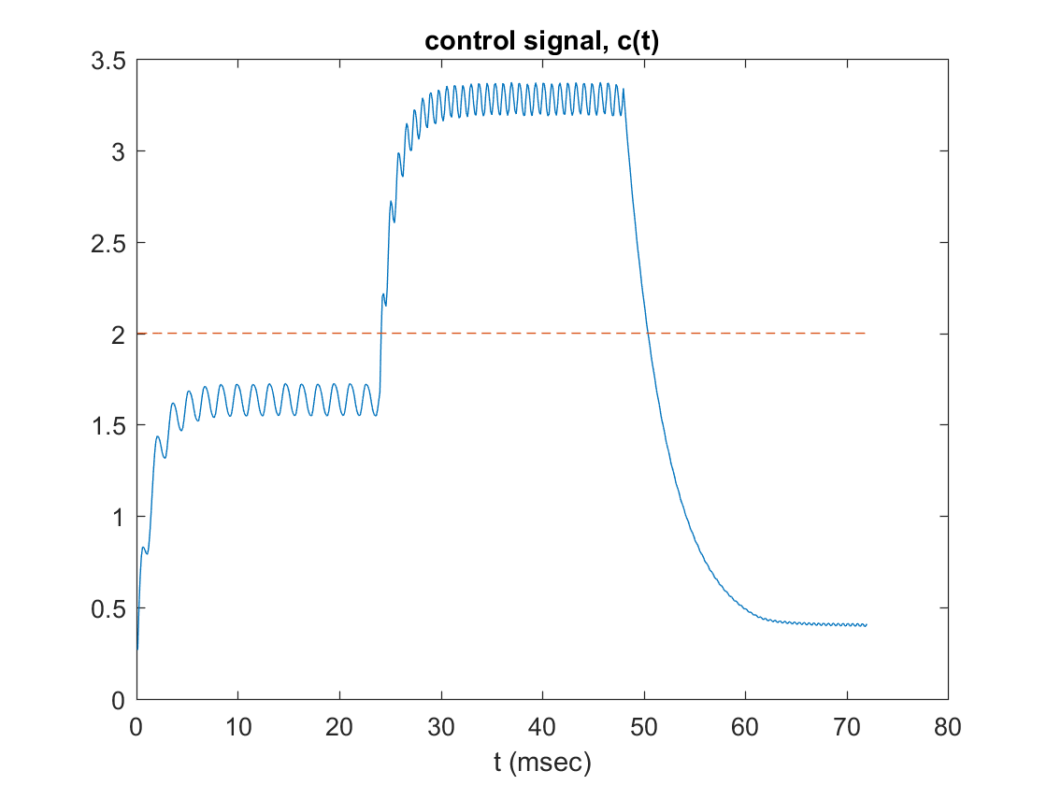
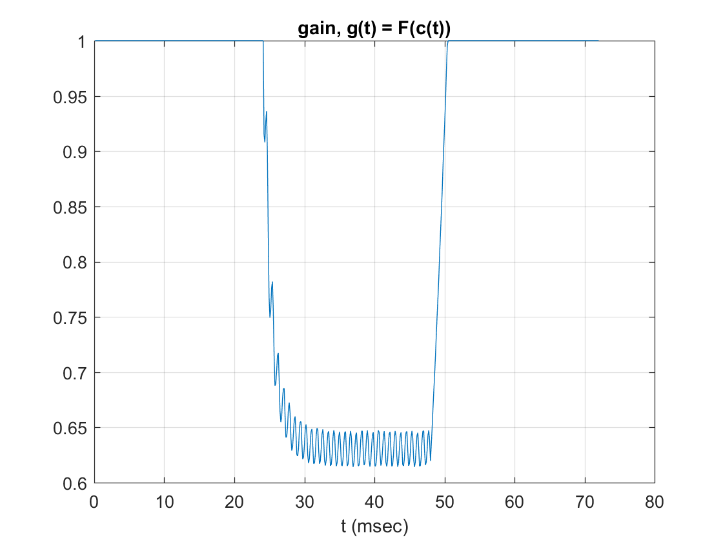
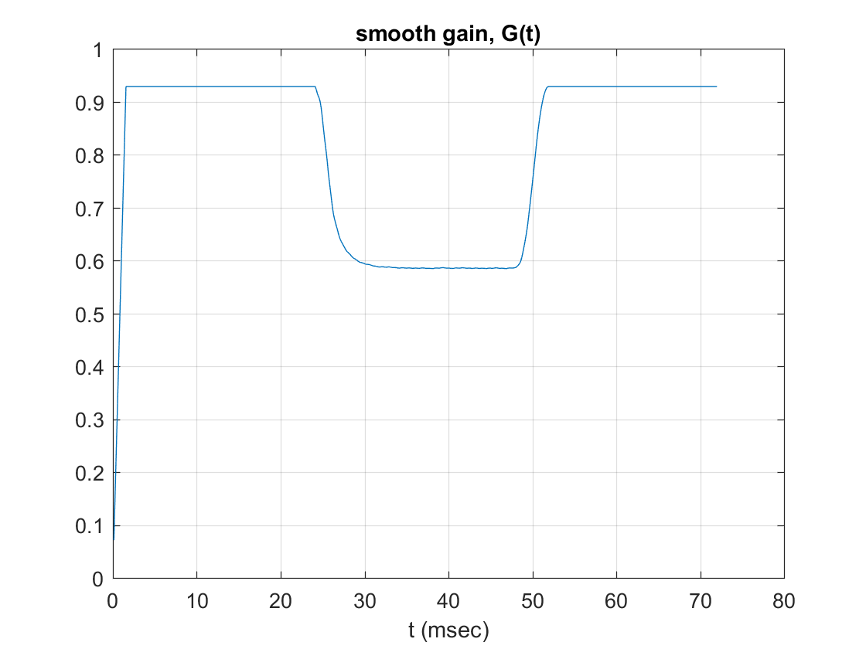

Part F Expander
% For an expander p should be around 2-4
p = 4;
c0 = 0.95;
MvAvgBuf = zeros(1,L);
pt = @(i) mod(i,L-1) + 1;
MvAvgSum = 0;
MvAvgOld = 0;
cPrev = 0;
c = zeros(1,length(x));
g = zeros(1,length(x));
% Level detector
cN = @(xn,cPrev) (LbAtck* cPrev + (1-LbAtck)*abs(xn)).*(abs(xn) >= cPrev) ...
+ (LbRels*cPrev + (1 - LbRels).*abs(xn)).*(abs(xn) < cPrev);
% Gain Processor functions both Compressor and Expander
gCom = @(c) (c/c0)^(p-1)*(c>= c0) + 1*(c <=c0);
gExp = @(c) (c/c0)^(p-1)*(c <=c0) + 1*(c>= c0);
% Since we are compressing the signal I will use gCom
for i = 1:length(x)
xn = x(i);
c(i) = cN(xn,cPrev);
cPrev = c(i);
g(i) = gExp(c(i));
MvAvgOld = MvAvgBuf(pt(i-1));
MvAvgBuf(pt(i-1)) = g(i);
MvAvgSum = MvAvgSum + g(i) - MvAvgOld;
G(i) = MvAvgSum/L;
y(i) = G(i)*xn;
end
figure;
plot(n*3/25,y, n*3/25, ones(1,length(n))*c0,'--')
title('compressor, y(t) = G(t)x(t)');
xlabel('t (msec)');
figure;
plot(n*3/25,c, n*3/25, ones(1,length(n))*c0,'--')
title('control signal, c(t)');
xlabel('t (msec)');
figure;
plot(n*3/25,g)
title('gain, g(t) = F(c(t))');
xlabel('t (msec)');
grid on;
figure;
plot(n*3/25,G)
title('smooth gain, G(t)');
xlabel('t (msec)');
grid on;
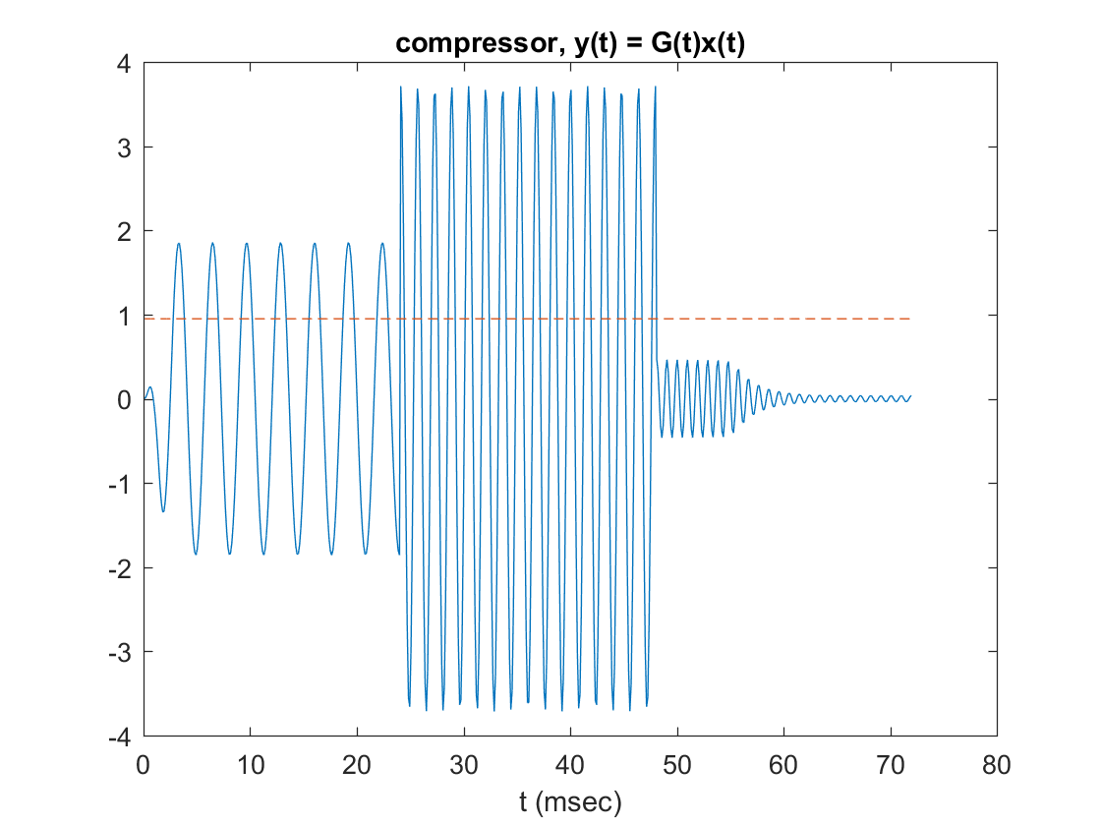
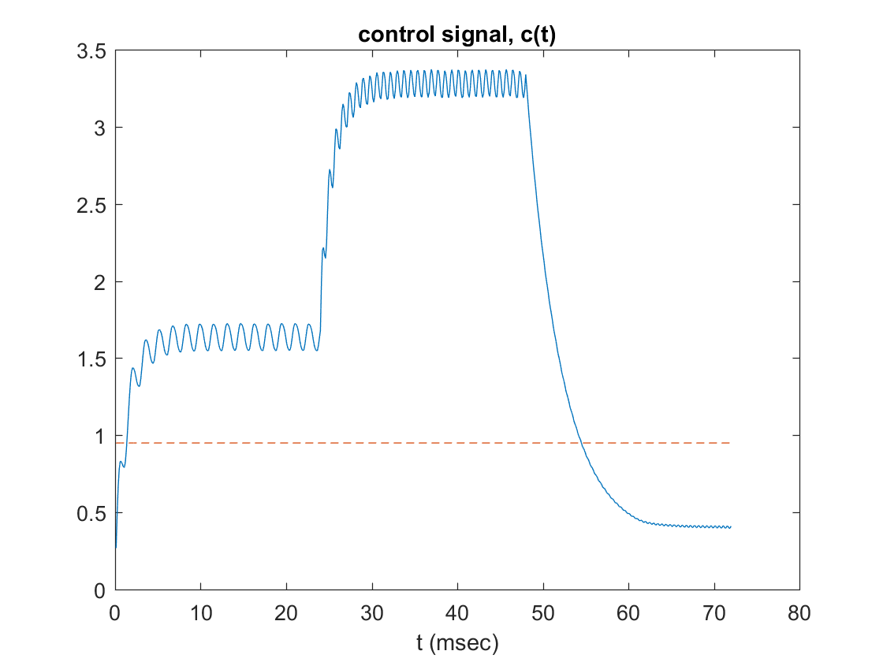
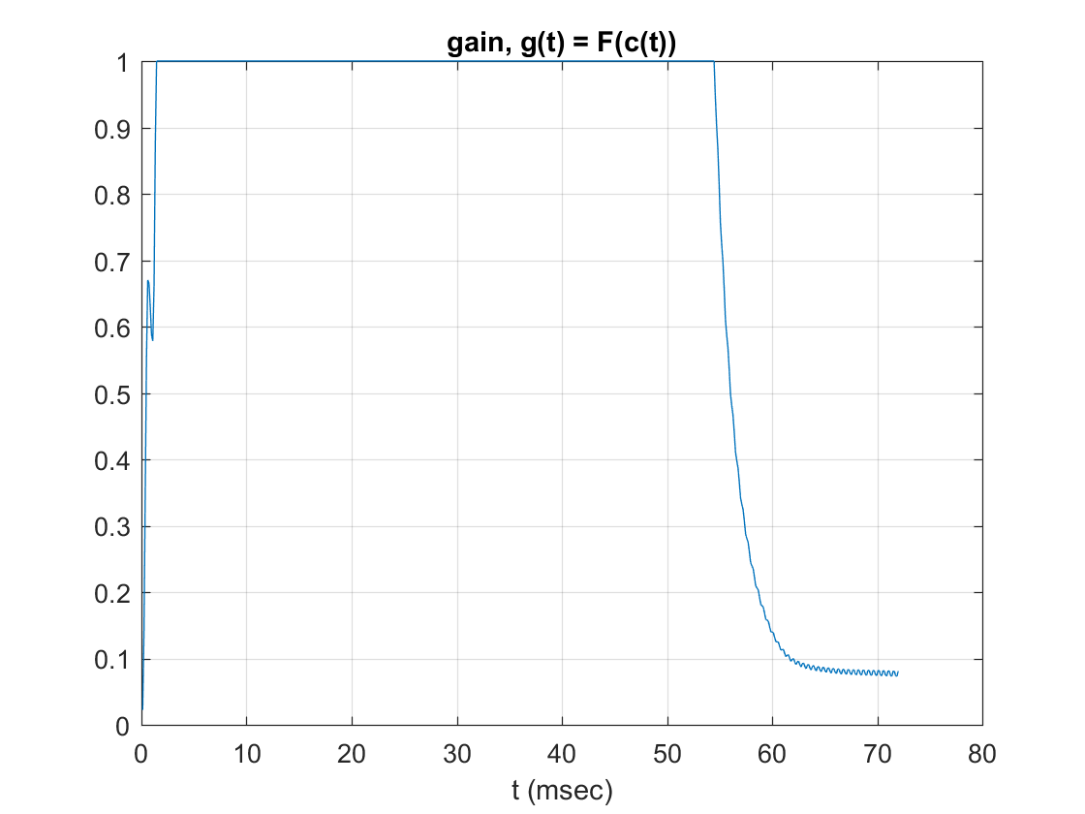
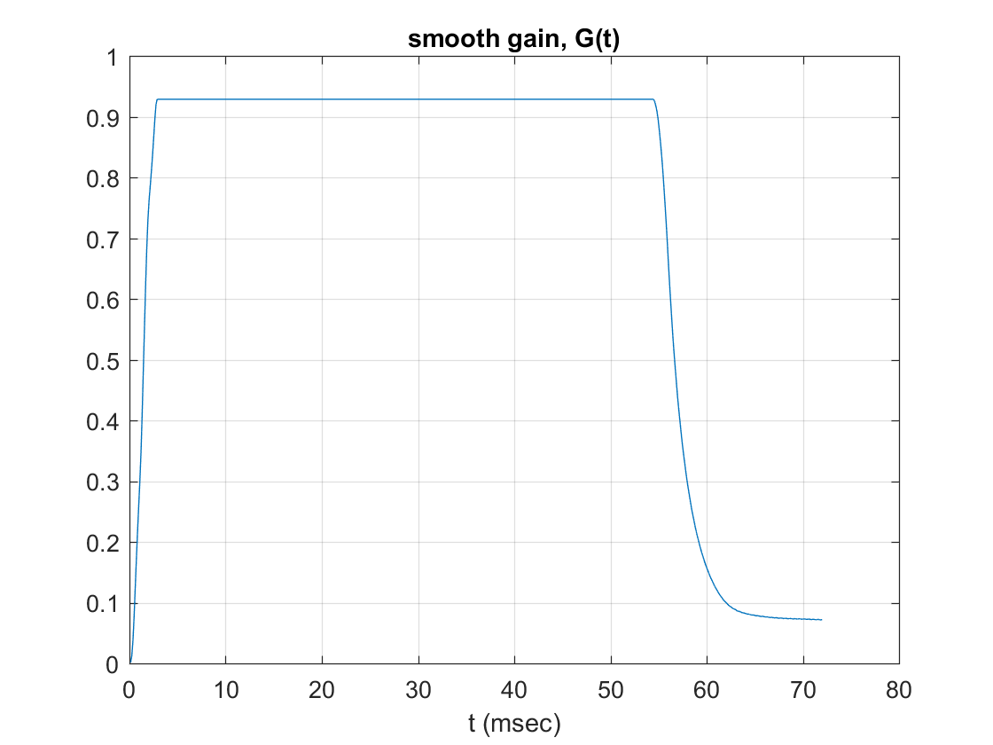

Part G Noise Gate: f1 & f3
% For a noise gate p should be much greater than 1, around 10+
p = 12;
c0 = 1.9;
MvAvgBuf = zeros(1,L);
pt = @(i) mod(i,L-1) + 1;
MvAvgSum = 0;
MvAvgOld = 0;
cPrev = 0;
c = zeros(1,length(x));
g = zeros(1,length(x));
% Level detector
cN = @(xn,cPrev) (LbAtck* cPrev + (1-LbAtck)*abs(xn)).*(abs(xn) >= cPrev) ...
+ (LbRels*cPrev + (1 - LbRels).*abs(xn)).*(abs(xn) < cPrev);
% Gain Processor functions both Compressor and Expander
gCom = @(c) (c/c0)^(p-1)*(c>= c0) + 1*(c <=c0);
gExp = @(c) (c/c0)^(p-1)*(c <=c0) + 1*(c>= c0);
% Since we are compressing the signal I will use gCom
for i = 1:length(x)
xn = x(i);
c(i) = cN(xn,cPrev);
cPrev = c(i);
g(i) = gExp(c(i));
MvAvgOld = MvAvgBuf(pt(i-1));
MvAvgBuf(pt(i-1)) = g(i);
MvAvgSum = MvAvgSum + g(i) - MvAvgOld;
G(i) = MvAvgSum/L;
y(i) = G(i)*xn;
end
figure;
plot(n*3/25,y, n*3/25, ones(1,length(n))*c0,'--')
title('compressor, y(t) = G(t)x(t)');
xlabel('t (msec)');
figure;
plot(n*3/25,c, n*3/25, ones(1,length(n))*c0,'--')
title('control signal, c(t)');
xlabel('t (msec)');
figure;
plot(n*3/25,g)
title('gain, g(t) = F(c(t))');
xlabel('t (msec)');
grid on;
figure;
plot(n*3/25,G)
title('smooth gain, G(t)');
xlabel('t (msec)');
grid on;
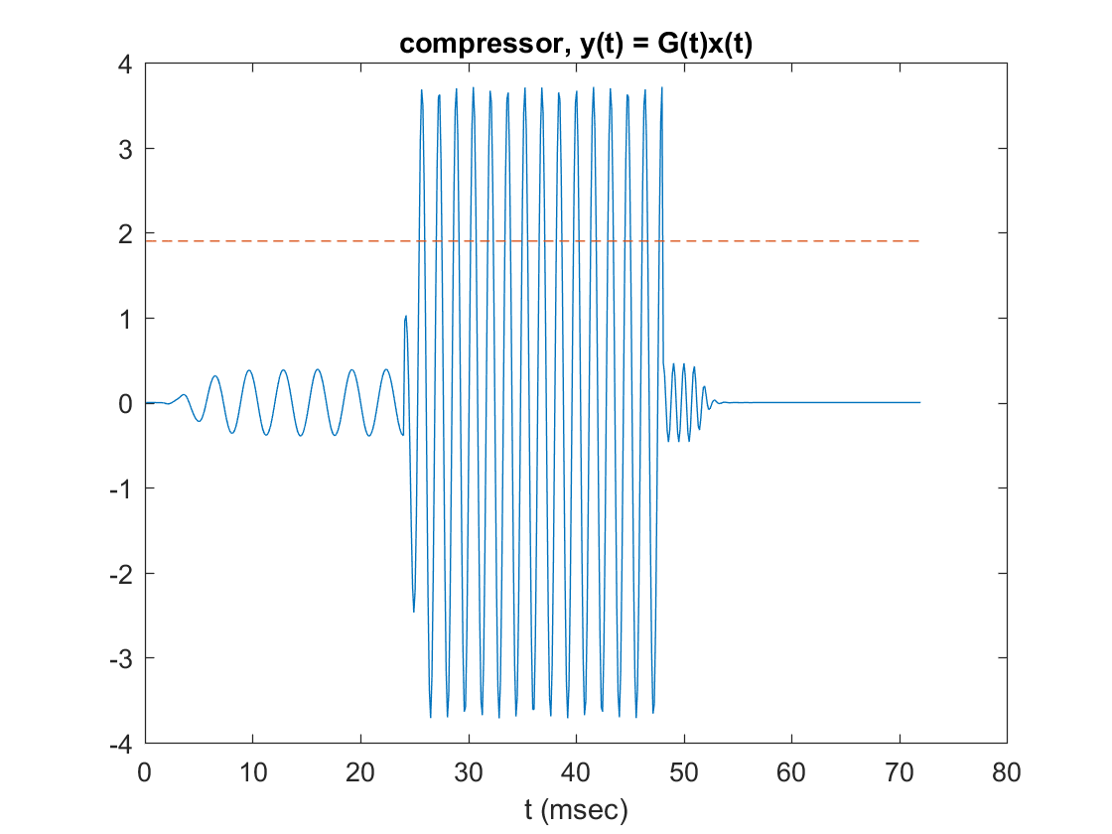
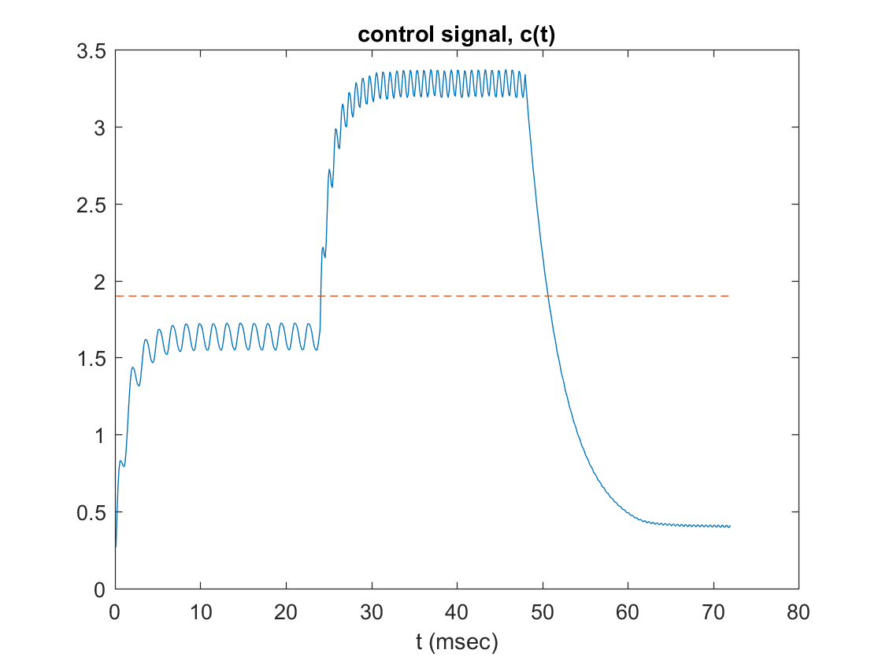
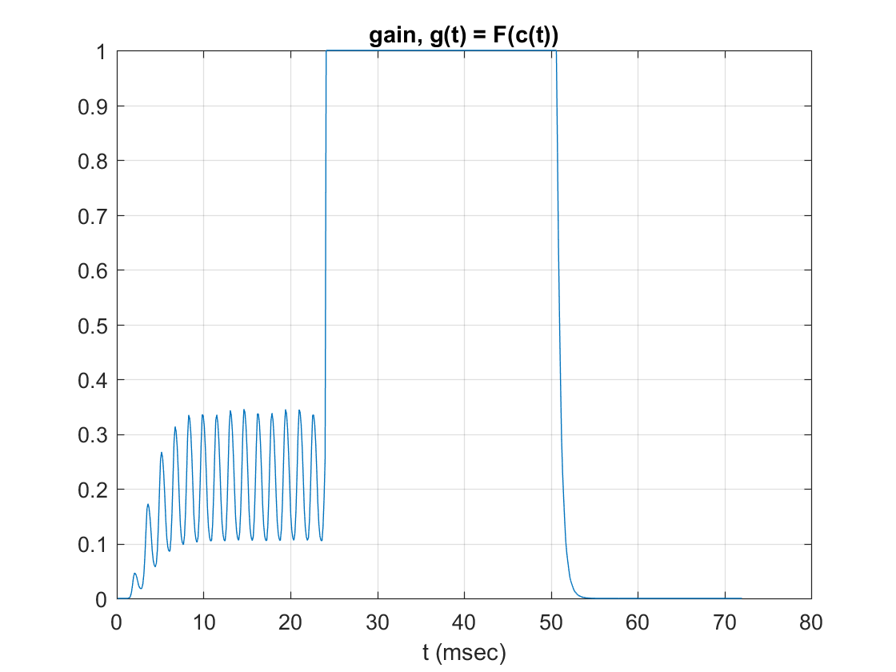
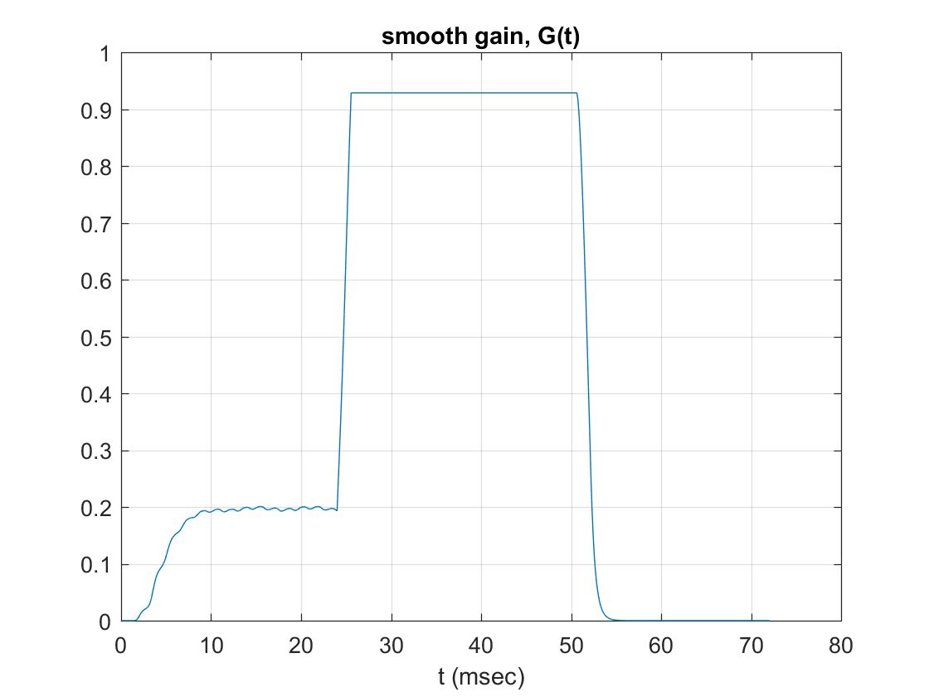

Part G Noise Gate: f3
% For a noise gate p should be much greater than 1, around 10+
p = 11;
c0 = 1.25;
MvAvgBuf = zeros(1,L);
pt = @(i) mod(i,L-1) + 1;
MvAvgSum = 0;
MvAvgOld = 0;
cPrev = 0;
c = zeros(1,length(x));
g = zeros(1,length(x));
% Level detector
cN = @(xn,cPrev) (LbAtck* cPrev + (1-LbAtck)*abs(xn)).*(abs(xn) >= cPrev) ...
+ (LbRels*cPrev + (1 - LbRels).*abs(xn)).*(abs(xn) < cPrev);
% Gain Processor functions both Compressor and Expander
gCom = @(c) (c/c0)^(p-1)*(c>= c0) + 1*(c <=c0);
gExp = @(c) (c/c0)^(p-1)*(c <=c0) + 1*(c>= c0);
% Since we are compressing the signal I will use gCom
for i = 1:length(x)
xn = x(i);
c(i) = cN(xn,cPrev);
cPrev = c(i);
g(i) = gExp(c(i));
MvAvgOld = MvAvgBuf(pt(i-1));
MvAvgBuf(pt(i-1)) = g(i);
MvAvgSum = MvAvgSum + g(i) - MvAvgOld;
G(i) = MvAvgSum/L;
y(i) = G(i)*xn;
end
figure;
plot(n*3/25,y, n*3/25, ones(1,length(n))*c0,'--')
title('compressor, y(t) = G(t)x(t)');
xlabel('t (msec)');
figure;
plot(n*3/25,c, n*3/25, ones(1,length(n))*c0,'--')
title('control signal, c(t)');
xlabel('t (msec)');
figure;
plot(n*3/25,g)
title('gain, g(t) = F(c(t))');
xlabel('t (msec)');
grid on;
figure;
plot(n*3/25,G)
title('smooth gain, G(t)');
xlabel('t (msec)');
grid on;
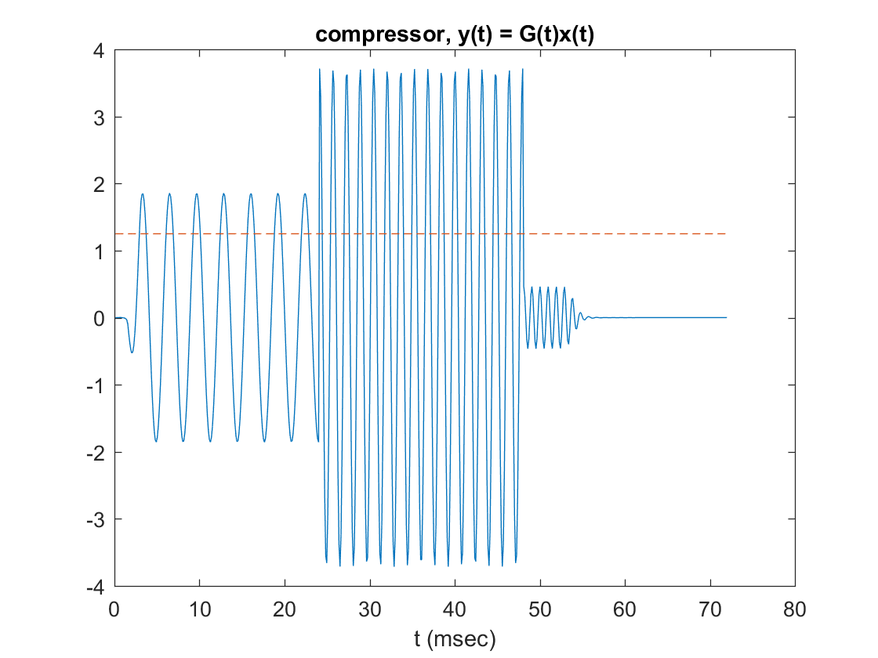
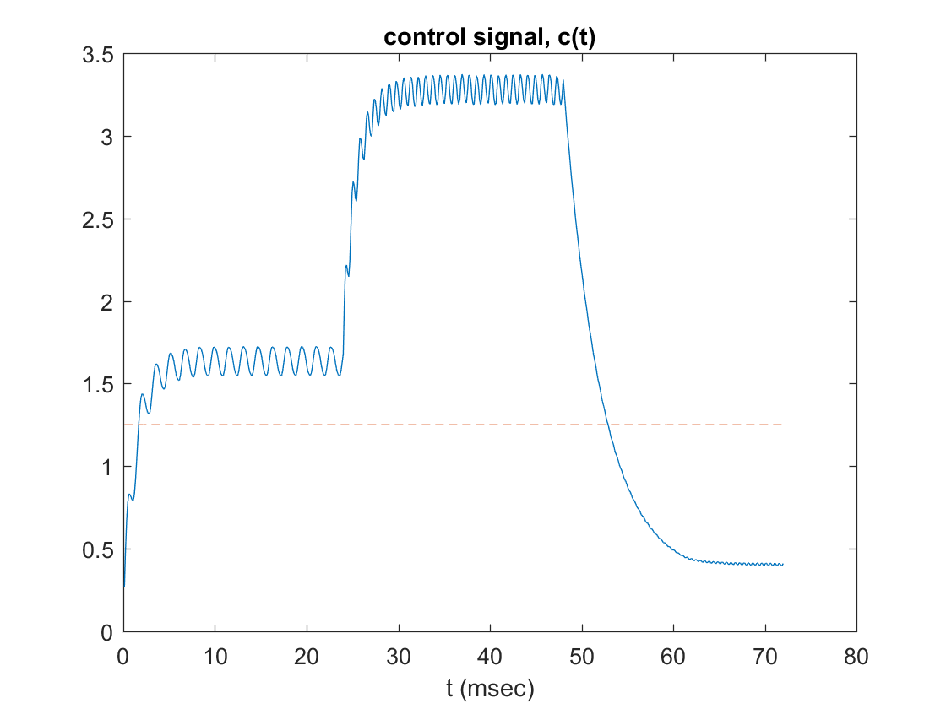
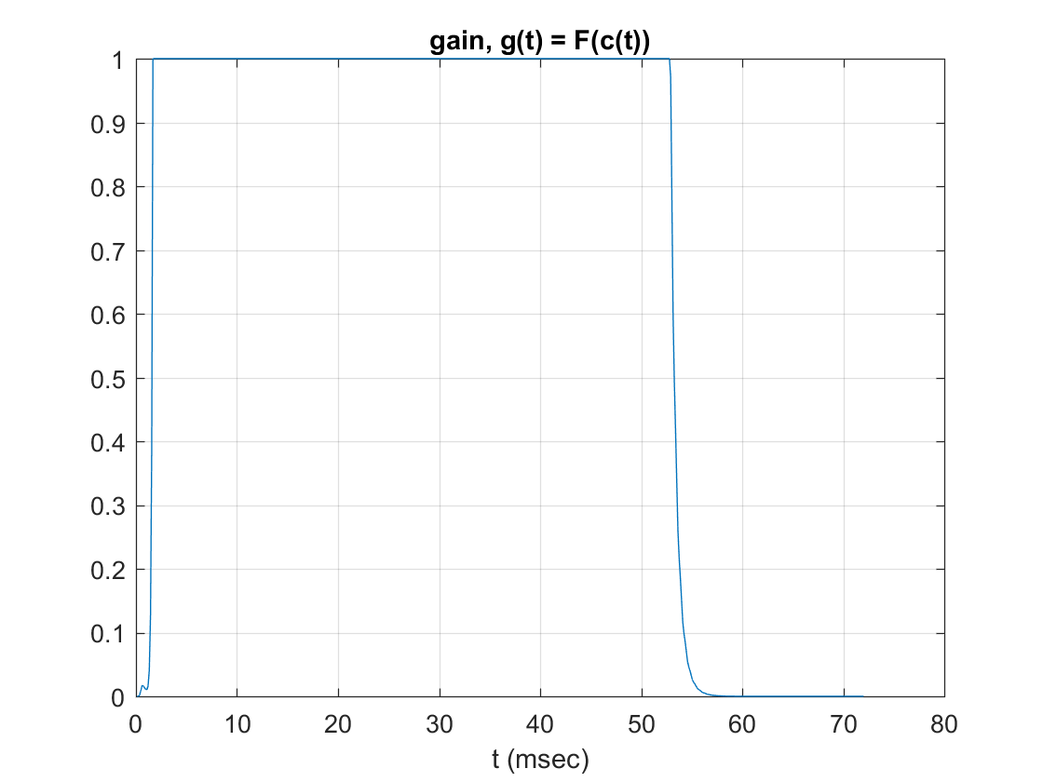
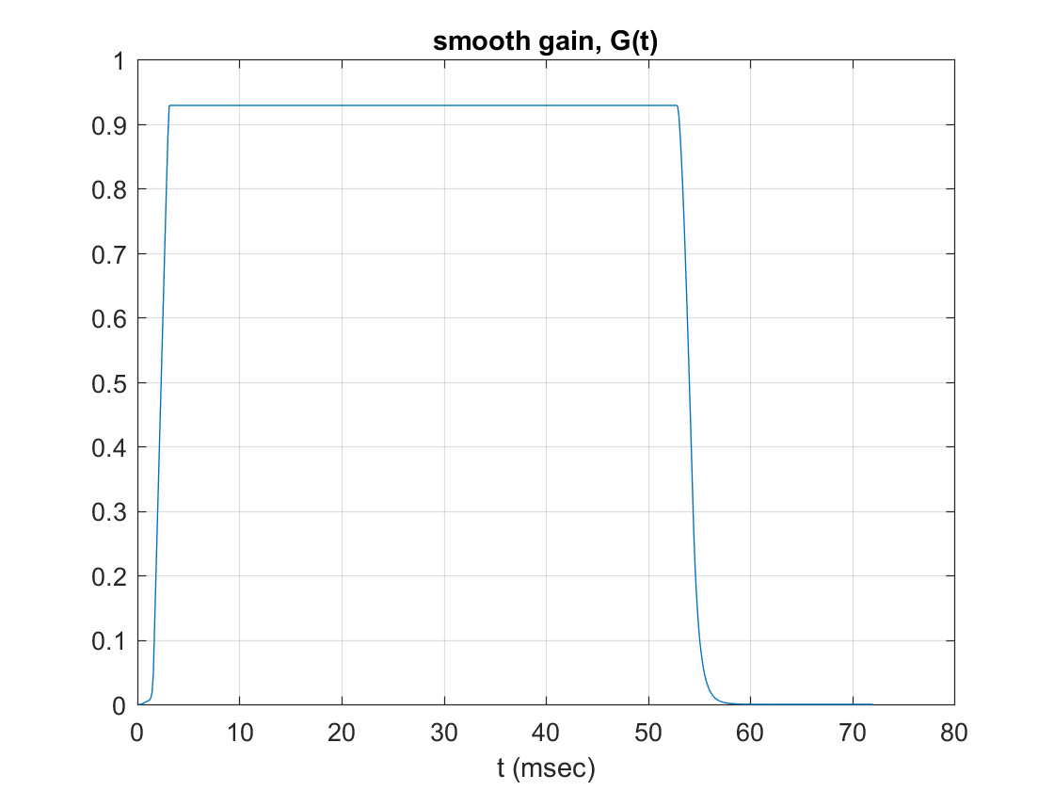

Part H
% Reading input files
[xs, fs] = audioread('speech.wav'); % Speech signal
[xm, fs] = audioread('music.wav'); % Music signal
% Plot of xs(t), xm(t) & xs(t) + xm(t)
n = 1:length(xs);
figure;
plot(n/44100, xs);
title('speech, xs(t)');
xlabel('t (sec)');
grid on;
figure;
plot(n/44100, xm);
title('music, xm(t)');
xlabel('t (sec)');
grid on;
figure;
plot(n/44100,xm +xs);
title('speech + music, x(t) = xs(t) + xm(t)');
xlabel('t (sec)');
grid on;
% Experimental values of p & c0
p = 1/10;
c0 = 0.005;
MvAvgBuf = zeros(1,L);
pt = @(i) mod(i,L-1) + 1;
MvAvgSum = 0;
MvAvgOld = 0;
cPrev = 0;
c = zeros(1,length(xs));
g = zeros(1,length(xs));
G = zeros(1,length(xs));
ym = zeros(1,length(xs));
y = zeros(1,length(xs));
% Level detector
cN = @(xn,cPrev) (LbAtck* cPrev + (1-LbAtck)*abs(xn)).*(abs(xn) >= cPrev) ...
+ (LbRels*cPrev + (1 - LbRels).*abs(xn)).*(abs(xn) < cPrev);
% Gain Processor, since we are compressing I've opted for the compressor
% function
gCom = @(c) (c/c0)^(p-1)*(c> c0) + 1*(c <=c0);
for i = 1:length(xs)
x = xs(i);
m = xm(i);
c(i) = cN(x,cPrev);
cPrev = c(i);
temp = gCom(c(i));
% When gCom is inputted 0 it produces NaN istead of outputting unity
% gain so an if statment takes care of that situation
if(isnan(temp))
g(i) = 1;
else
g(i) = temp;
end
MvAvgOld = MvAvgBuf(pt(i-1));
MvAvgBuf(pt(i-1)) = g(i);
MvAvgSum = MvAvgSum + g(i) - MvAvgOld;
gT = MvAvgSum/L;
G(i) = gT;
f = m*gT;
ym(i) = f;
y(i) = f +x;
end
figure;
plot(n/44100,y)
title('speech + ducked music, y(t) = xs(t) + G(t)xm(t)');
xlabel('t (sec)');
figure;
plot(n/44100,ym)
title('ducked music, ym(t) = G(t)xm(t)');
xlabel('t (sec)');
grid on;
figure;
plot(n/44100,c)
title('control signal, c(t)');
xlabel('t (sec)');
grid on;
figure;
plot(n/44100,g)
title('ducking gain, g(t)');
xlabel('t (sec)');
grid on;
figure;
plot(n/44100,G)
title('smoothed gain, G(t)');
xlabel('t (sec)');
grid on;
audiowrite('duckedSpeech.wav',y,fs);
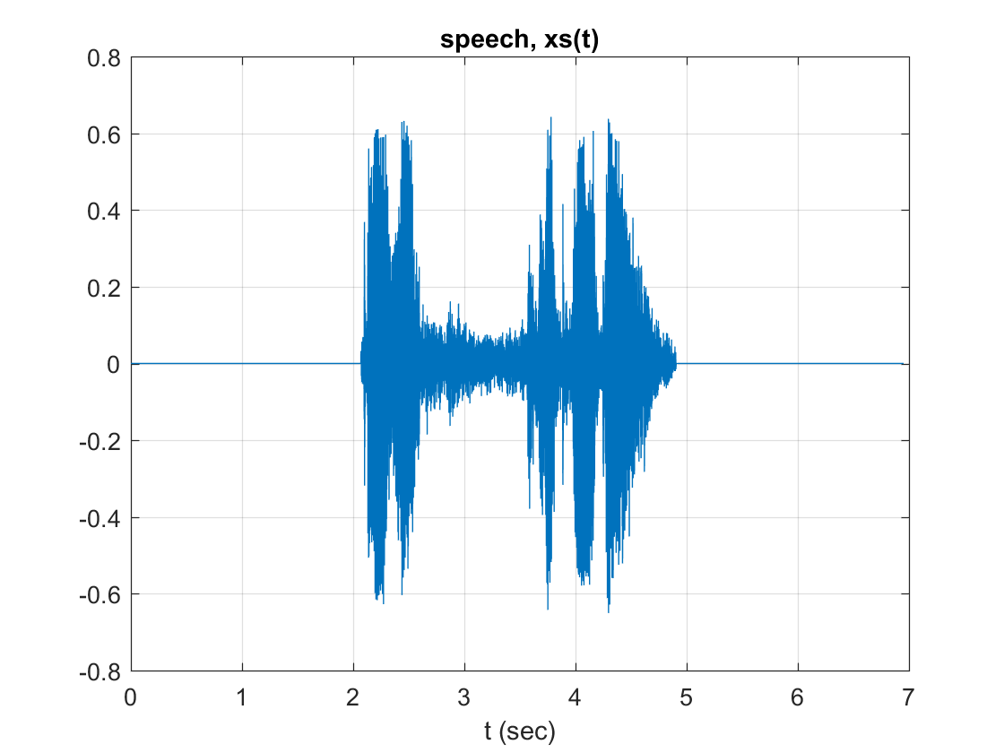
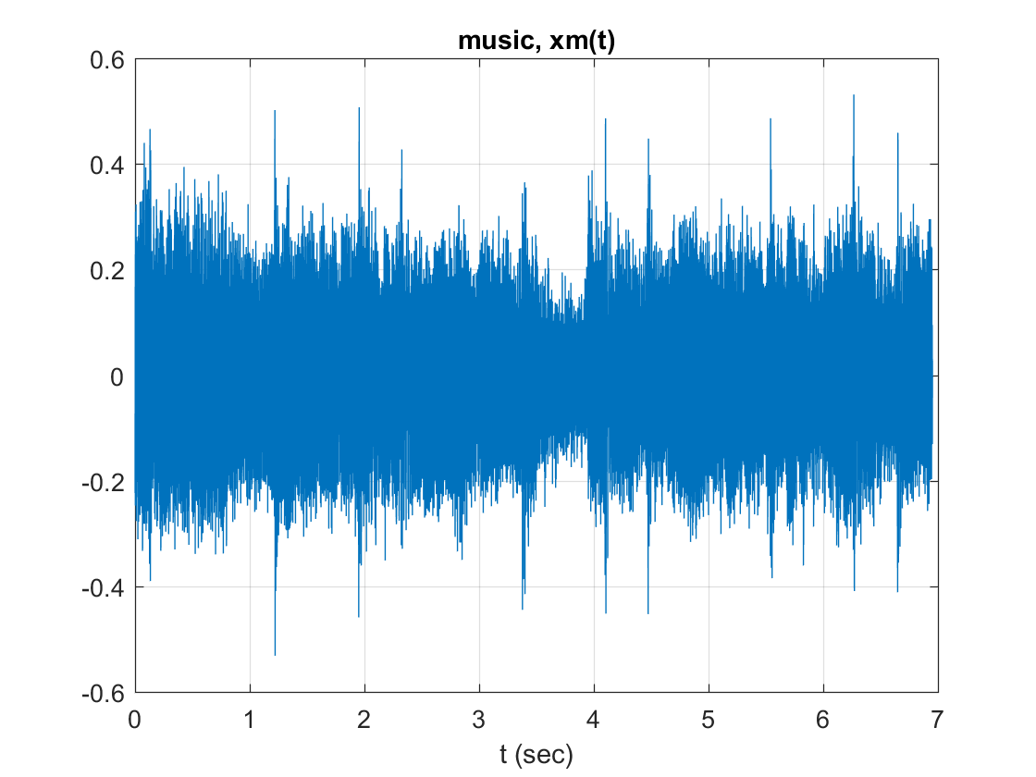
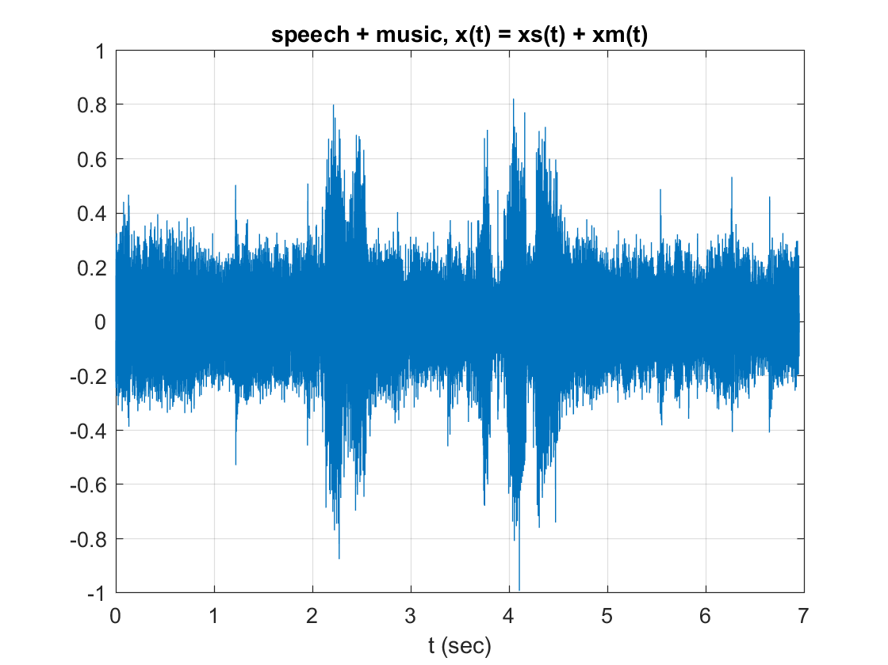
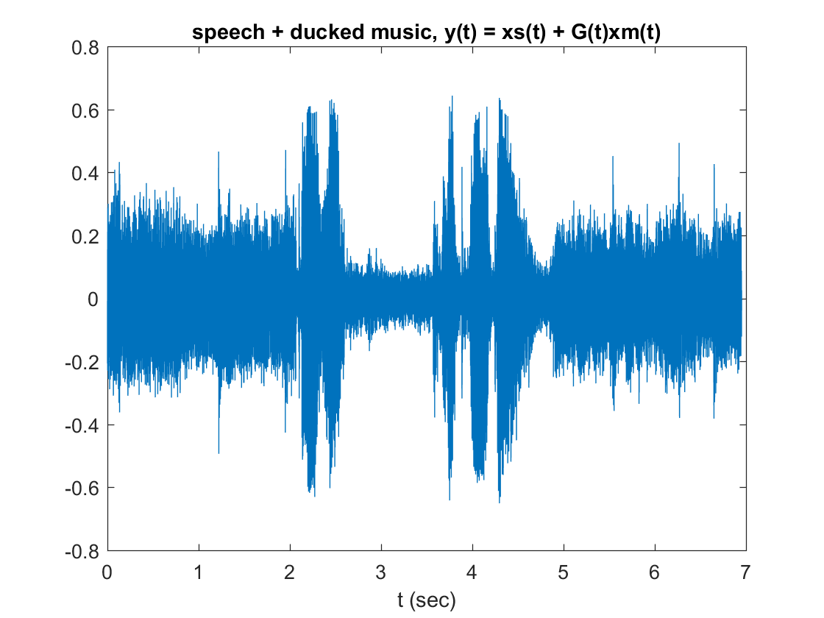
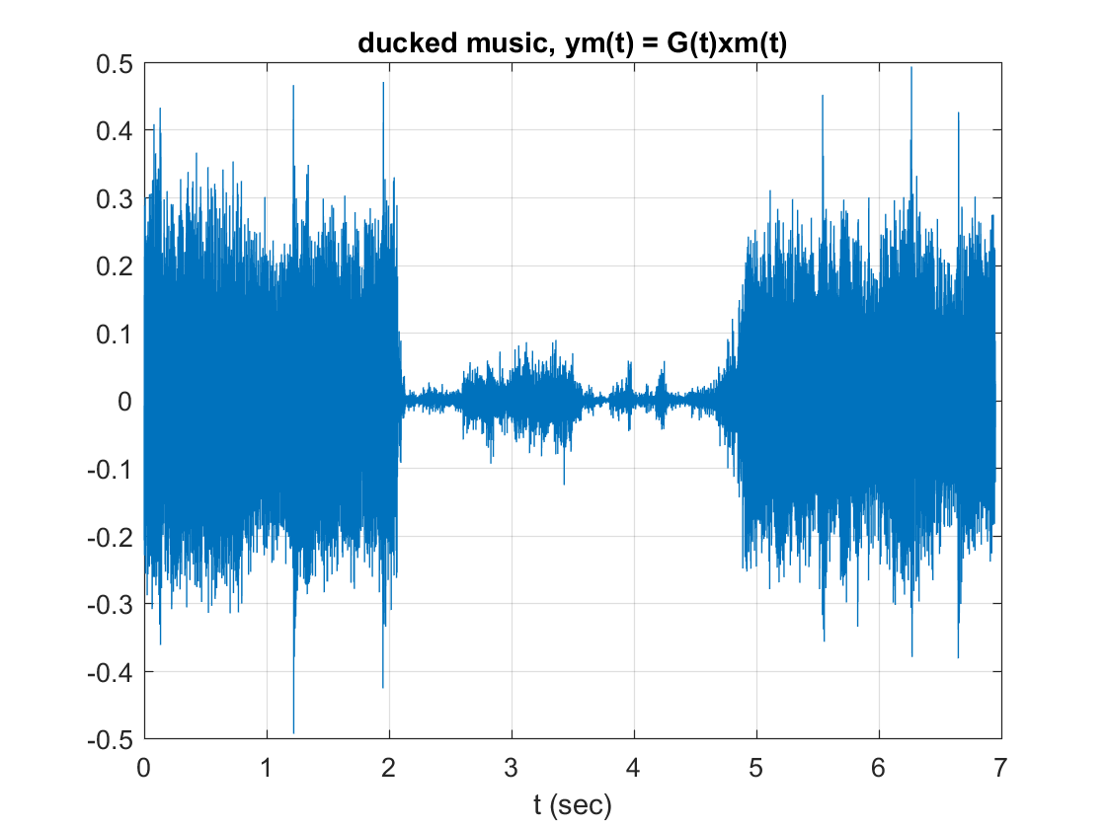
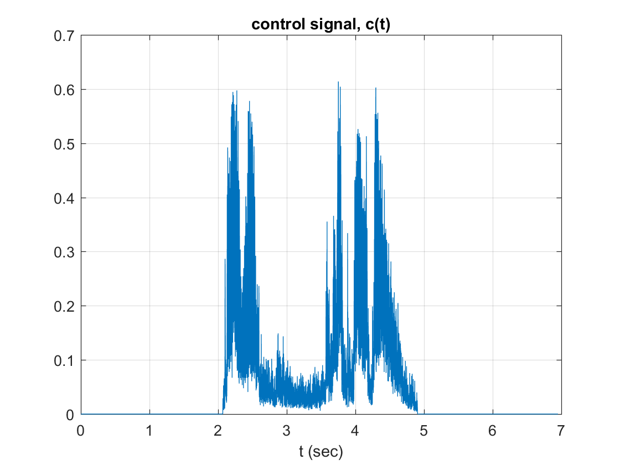
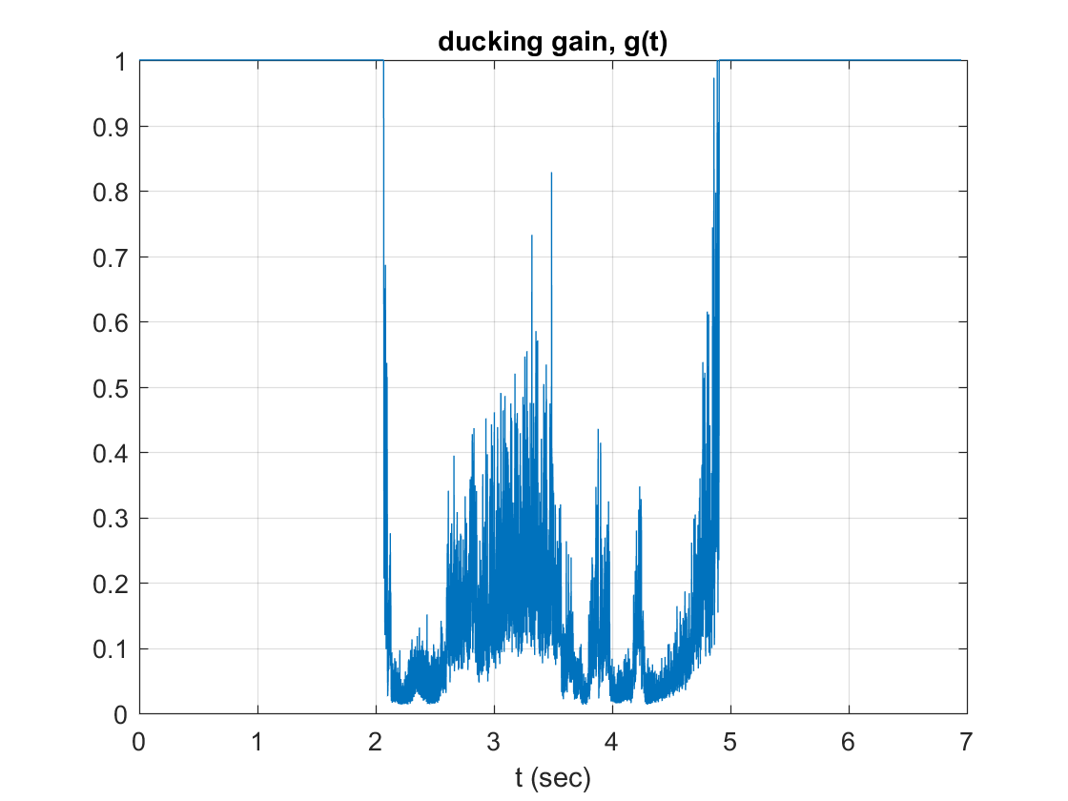
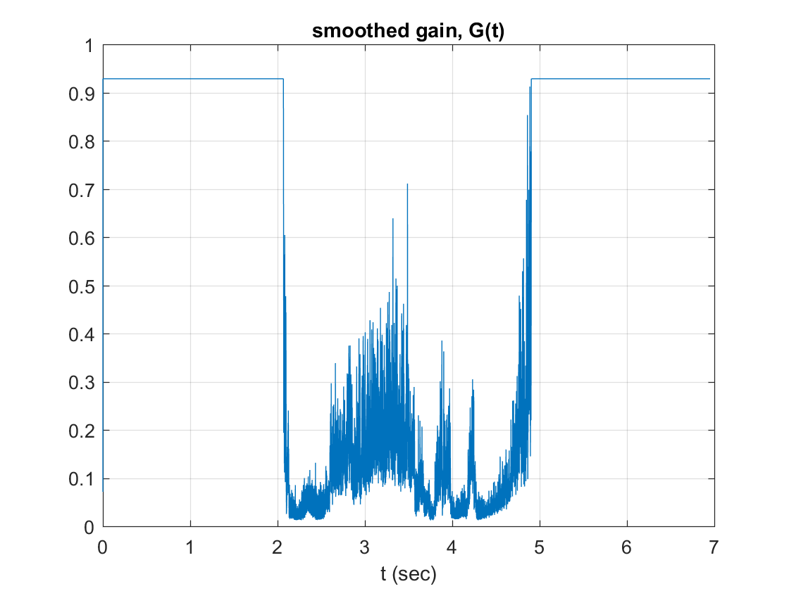
Published with MATLAB® R2016b

